Entity Framework Installation

- First need to open Restaurants.Infrastructure.csproj and check the item group. Currently we have only 1 itemgroup which is ProjectReference.
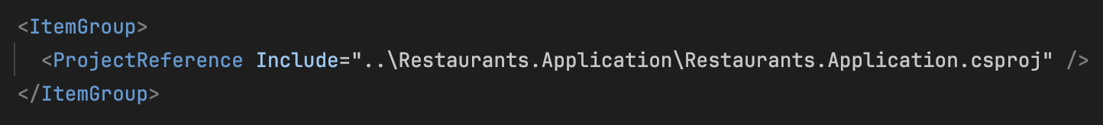
- Now we need to add one more itemgroup which is PackageReference (similar to add nuget package)
- Add nuget package (SQL server database):
  - Right click at Restaurants.Infrastructure and add nuget package.
  - Search for Microsoft.EntityFrameworkCore.SqlServer
  - Select the version and currently use 8.0.22
  - Install it
- If you Postgresql use similar step as step 3 but search for:
  - Npgsql.EntityFrameworkCore.PostgreSQL
- Now check we have 2 itemgroup already:
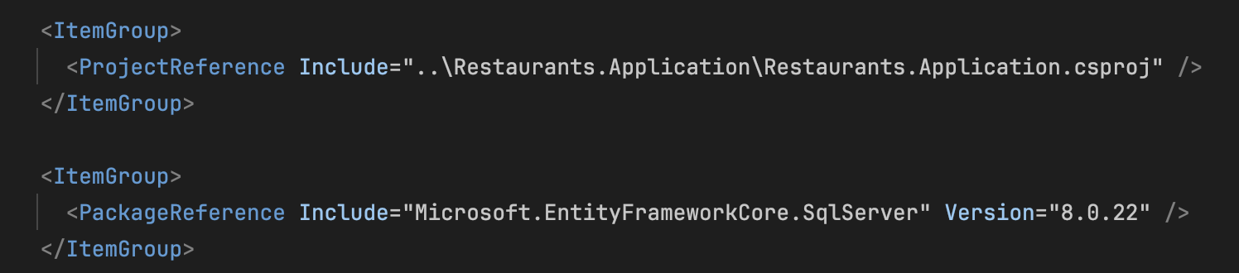
- Add nuget package in Restaurants.Api:
  - Microsoft.EntityFrameworkCore.Design

